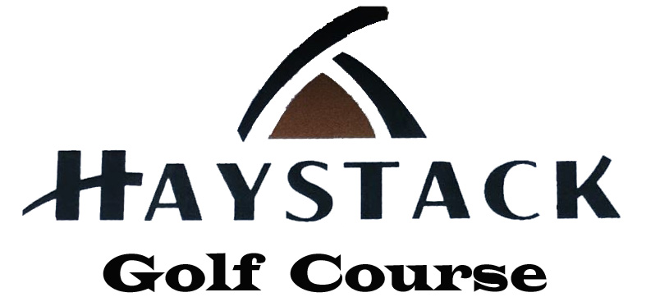

Hello Competitors,
I would like to take a moment to introduce ourselves and our golf course. We are Haystack Golf Course in Wilmington, Vermont and my name is Johnny Cleanthes, PGA. We learned that The Sarah L. Hunter Spring Classic has not secured a course to play. We would like to officially and cordially invite The Sarah L. Hunter Classic to Haystack Golf Course on May 19th and 20th, 2023. I am familiar with the tournament format since I have worked on it in the past, so the tournament will be run in the same format that has been used in the past. Please know it is our intention to send out entry forms very soon, however we will limit the field to the first 50 teams who complete their entry form with their entry fee. The tournament entry period will open the day we send out the forms with a deadline of April 28th. Once we receive the 50 teams, we will start a wait list. Attached please find a draft of the tournament flyer that we intend to circulate to the lady members of our course.

Professionally,
The Owners of Haystack Golf Course
Johnny Cleanthes, PGA & Kathryn Cleanthes
Patrick & Maria Aubry

The Sarah L. Hunter Spring Classic
$500 per Non-Member & Non-Member
$450 per Member & Non-Member
$400 per Member & Member
Your Entry Includes:
- One practice round & two tournament rounds
- Golf cart for the two tournament rounds
- Continental breakfast both days, Friday dinner banquet, and Saturday awards luncheon
- Tee gift and tournament prizes
FORMAT:
- 36 Hole Better Ball of Partners using 80% Course Handicap
- Field is divided into flights by Team Gross Score after Round One
- Gross & Net Prizes in each flight
- Ties for Low Gross in Championship Flight will be decided by a sudden death playoff, All other ties decided by USGA recommended match of cards
- Friday Skins Contest (shop credit)
SCHEDULE:
- Practice Round- Any day prior to the event and after May 1st
- Friday – 10:30 am Shotgun
- Friday Dinner Banquet at The Stack Restaurant @ Haystack Golf Course- Cocktails at 6:00pm, Banquet 7pm
- Saturday- 8:30 am Shotgun
- Luncheon, Raffle and Awards Ceremony following Golf
Notes:
- Golf Dress Policy- Proper golf attire is required.
- Friday Dinner Dress- Smart Casual- no jeans please
- Cancellations- Refunds issued only if a replacement team is secured.
- Skins- Cash sign-up for Friday Team Skins at registration
** Snow Date – June 1st and 2^{nd **}

