Liaisons or Admin
Steps for Scoring WITH FORWARD TEES in Golf Genius v11
2020
- Login to Golf Genius at www.golfgenius.com
  - Enter your email address and password

Note that steps 1-3 may already be done by the club rep; if not, then the liaison will need to make sure these steps are done.

Make sure that the event roster in Golf Genius matches the actual player field. You may need to delete or add players:

- Delete Players (use this for players that are in the roster that need to be removed)
Golfers->Event Roster use the pull down in the ACTIONS column at the far right of the players name and select delete and ok to remove the player.
- Add Players:
  - Golfers -> Import Golfers from Master Roster/GHIN/Other (center column)
  - Make sure that Master Roster and Quick Search in Master Roster radio buttons are selected. Make sure the Include all custom fields button is selected (see the screen shot on the next page)
  - In the Quick Search field, enter the first three letters of the players last name. They will appear in the drop down. Click the Add Player button and they will get added to the roster. 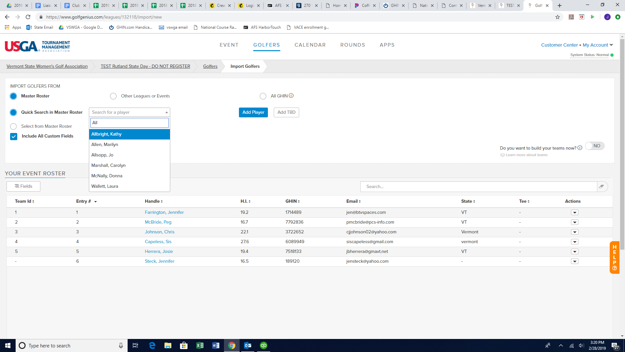
    - If they are golfing from the forward tees, you must go into their event profile and indicate that.
      - Go to Golfers/Event Roster/Click on their name/Click on the Custom Fields tab and click yes on the Forward Tees Indicator
    - If they are a “Bring a Friend”, you must go into their event profile and indicate that.
      - Go to Golfers/Event Roster/Click on their name/Click on the Custom Fields tab and click yes on the “Are you a Guest for Bring a Friend?”

  - Put Added Player into Teams
Rounds->Edit Existing Pairings (center column)
- At the bottom of the page click Add Players
The names of the players you added will show up when you click Add Players. Click on a player then click on any empty space in the pairings. If you don’t have any empty spaces click New Row first.
Note: If a pop up message appears saying “One or more other changes that you have made could impact this round…”, click on CONTINUE

- If you had to add a row, Select the “Set course and Tee” button, select the players that were added, and at the bottom select the tees that they golfed from. Click “Go”.

- Click SAVE PAIRINGS
BE SURE TO CLICK SAVE PAIRINGS AT THE BOTTOM RIGHT CORNER ‎
- Enter Scores
Rounds->Enter Scores (middle column)
Select Tournaments->State Day Results
Open pairings by hitting the check mark at the right of each tee time group and enter the scores. It will auto advance thought the players in that foursome.
If a player does any of the following: Does Not Finish (DNF), No Card (NC), Withdraws (WD), Disqualified (DQ), Doesn’t Show UP (NS) do the following.
Click on the players name (where you are entering scores) and a pop-up will appear. It will have the players name and a status of Active. Under Change Status there will be a box with the word Active and a pull down. Use the pull done and select the appropriate action. The select Save.
Select Done when finished entering score for a pairing.
Select Done Entering Scores when you are finished entering scores for all players in the event.

- Update Handicaps
NOTE: IF YOU ARE DOING THE SCORING ON A DATE AFTER THE DAY OF THE EVENT, CLICK THE “UPDATE METHOD” PULL DOWN AND THEN SELCECT “HANDICAP INDEX ON A SPECIFIC DATE”, SELECT THE DATE OF THE STATE DAY, THEN RUN UPDATE.

    - Golfers->Access GHIN to Update Handicap Indexes
    - On new page that pops up hit the Update button
      - Make sure the Status says “updated” for everyone; make note of anyone that doesn’t have a handicap

- Create Flights (note if your event has forward tees offered you will be creating a separate flight for those players)
How to calculate the total number of flights for an event:
We have decided that friends and people without handicaps (NH) will be in their own flight. We have also decided that forward tee players will be in their own flight. So to calculate the number of flights for the remainder of the field, you need to figure:
Total players for regular flights = Total Field – friends – forward tee players
For example, say there is a total field of 44 players, but 2 of them are friends, and 3 are forward tee players.
That means we need:
- One flight for friends (2 players in this flight) & NH
- One flight for forward tee players (3 players in this flight)
- Two flights for the rest of the field (44 – 2 - 3 = 39 players in this flight)

Note if a “friend” is a forward tee player they will go into the friend flight, not the forward tee player flight.

START HERE For SD Events with “Bring a Friends”:
      - Golfers->Events/Divisions/Flights/Teams (center column toward bottom)
      - Select “Add New Division” / “Using a Custom Field”
      - Select “Are you a Guest for Bring a Friend?”
      - Select Next
      - A new division will be created. Rename this division to “Friend Flight” by clicking on “edit name” and type in “Friend Flight”
      - Delete the “No” Division

START HERE IF NO FRIENDS

For SD Events with Forward Tees:
  - Golfers->Event Divisions/Flights/Teams (center column toward bottom)
  - Select “Add New Division” / “Using a Custom Field”
  - Select “Would you like to golf from the forward tees?”
  - Select Next
  - Two new divisions will be created, a No division and a Yes Division. You need to Rename these by clicking on the “Edit Name” button:
        - Rename No to “Regular Tees Division”
    - Rename Yes to “Forward Tee Flight”
      - Make Sure Golfers are only in one division
        - Go to Golfers->Event Divisions/Flights/Teams
        - Click on the “Compare Divisions” Button (far right)
        - Make sure all three boxes are checked (if forward tee players and guests are part of the field)
        - Click on “Show players part of at least two divisions” button
        - The priority of divisions are “Friend Divison” , then “Forward Tee Division” , then Regular Tee Division”. So for example, if a player is part of the guest divison and the forward tee division, you should unclick the forward tee division. A PLAYER MUST ONLY BE PART OF ONE DIVISION.
        - Continue below
      - In the Regular Tees Division, click on the “Manage Flighted Golfers” button
  - Select:
        - Autofill Flights
        - Flight By: Handicap Index
  - Number of Flights
          - 1-20 players = 1 Flight
          - 21-40 players = 2 Flights
          - 41-60 players = 3 Flights
          - 61-80 players = 4 flights
          - 81-120 players = 5 flights
  - Select Next at the bottom right of page
  - On the next page you will see something like this
Flight Name Golfers/Flight
Flight 1 20
Flight 2 18
The flights may not be divided evenly divided.
Click on the box that players with the same handicap should be in the same flight
- Click Next at the bottom right of page.
You will see the names of the Flights and the people in those flights. You will not see the handicaps of the players yet.
- to Rounds/Tournaments/State Day Results/ Divisions
        - Click Forward Tees & Regular Tee Division (& Friends Flight, if there are Friends playing)
        - Click Save at the bottom
- To see what it would look like on the website go to Rounds/Display Leaderboard.
- Go to Golfers/Events Divisions Flights &Teams
        - Click on Regular Tee Division/Manage Flighted Golfers/Print Reports
        - Click on Forward Tees/Manage Flighted Golfers
        - At the far right just below the dark blue border, you will see a print flights button. Click the Print Flights button and select Handicap Index to see the HI of the players in each flight. A page will come up saying preparing document. When it is finished click Download PDF to view the flight with the player names and handicap.
- If this looks okay, you can move on. If not, you can edit the flights.

- Edit Flights (if needed)
- Select Edit Membership under the flight you want to move the player from.
- A page appears with a red x beside the name of each player on the list.
- Click on the red x the players you want to move.
- Players are moved to available players.
- Click on Save in bottom right corner of page.
- Use the Change Flight pulldown to choose the flight where you want to put the players.
- Click the name of the Available Player you want to move.
- The player will be moved to that Flight.
- Click on Save in the bottom right corner.
- If you want to check the flights again go back to Golfers->Event Divisions/Flights/Teams
- Select Manager Golfers at bottom of page. The changes you have made should be there.
- Repeat as often as you like.

- Finish
Select Rounds
In the right column near the bottom, make sure that Allow GHIN Updates and Show Results in Event Portal are showing Yes.
Click completed at the bottom right.
Not Started In Progress Completed

- Post Scores to GHIN
Rounds->Post Scores to GHIN (center column next to bottom)
A new page will pop-up. At the top of the page it will say:
Filter By A Custom Field
- Be sure to change Home to Away using the drop down.
Score Type: Away
Then Click POST SCORES
A page comes up with the names listed and a place in the right most column that turns green when the score is posted. If it turns red instead, there is a problem.
Continue on regardless of whether you got errors with a few players when posting scores but let us now on the financial report which players wouldn’t post.

- DISPLAY LEADERBOARD
  - Click Rounds -> Display Leaderboard to see what the website will look like
  - Also check the results portal for accuracy: https://www.golfgenius.com/pages/1318796
- Sending out the Results
Golfers->Manage Emails
Click on Compose Emails (upper left)
On second line – Golfers Options select Check All Golfers and select Jen Farrington, Dana Cassidy and Sis

At this point everyone’s name should have a check beside it.
Subject Use this format. 2020 <the club name> State Day Results
You must have a title or it won’t send the email.
Compose the email in the message box.
Be sure you include the following statement somewhere in your message.
“The State Day Winners and Points will be sent later. These results are for Gross and Net Scores only. The left-hand column should be ignored in the results as it is not consistent with the way that the VSWGA determines winners and points.
If you feel your score was posted incorrectly, you have 24 hours to notify statedays@vswga.org
The official winners and points will be posted at https://vswga.org/state-days/2020-schedule/ within a few days of this event.”
Put a link to the results in the message.
Go to the top of the page and click Apps.
On the top left of the page you will see a link that looks like vswga2020<nameofyourclub>stateday.golfgenius.com.
Copy that link (using “Ctrl C” or right click and copy link address) and then scroll back down to the bottom of the page to your message. Insert the link using “Ctrl V” or right click and click paste.
In the bottom left corner hit SEND

Have questions? Having issues?
Call Jen Farrington 802-363-0170 OR
Peg McBride 802-222-1220

