Liaisons or Admin
Steps for Scoring in Golf Genius v7
2019
- Login to Golf Genius at www.golfgenius.com
  - Enter your email address and password

Note that the followng steps 1-3 may already be done by the club rep; if not, then the liaison will need to make sure these steps are done.

Make sure that the event roster in Golf Genius matches the actual player field. You may need to delete or add players:

- Delete Players (use this for players that are in the roster that need to be removed)
Golfers->Event Roster use the pull down in the ACTIONS column at the far right of the players name and select delete and ok to remove the player.
- Add Players:
  - Golfers -> Import Golfers from Master Roster/GHIN/Other (center column)
  - Make sure that Master Roster and Quick Search in Master Roster radio buttons are selected. Make sure the Include all custom fields button is selected (see the screen shot on the next page)
  - In the Quick Search field, enter the first three letters of the players last name. They will appear in the drop down. Click the Add Player button and they will get added to the roster.
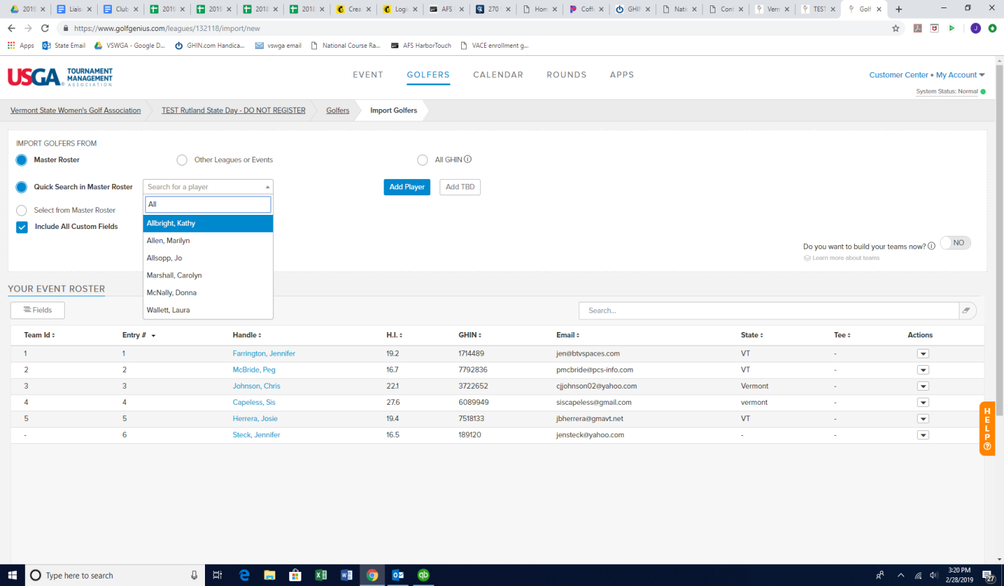
    - If they are golfing from the forward tees, you must go into their event profile and indicate that.
      - Go to Golfers/Event Roster/Click on their name/Click on the Custom Fields tab and click yes on the Forward Tees Indicator

  - Put Added Player into Teams
Rounds->Edit Existing Pairings (center column)
- At the bottom of the page click Add Players
The names of the players you added will show up when you click Add Players. Click on a player then click on any empty space in the pairings. If you don’t have any empty spaces click New Row first.
Note: If a pop up message appears saying “One or more other changes that you have made could impact this round…”, click on CONTINUE

- If you had to add a row, Select the “Set course and Tee” button, select the players that were added, and at the bottom select the tees that they golfed from. Click “Go”.
- Click SAVE PAIRINGS
BE SURE TO CLICK SAVE PAIRINGS AT THE BOTTOM RIGHT CORNER ‎
- Enter Scores
Rounds->Enter Scores (middle column)
Select Tournaments->State Day Results
Open pairings by hitting the check mark at the right of each tee time group and enter the scores. It will auto advance thought the players in that foursome.
If a player does any of the following: Does Not Finish (DF), No Cards (NC), Withdraws (WD), Disqualified (DQ), Doesn’t Show UP *NS) do the following.
Click on the players name (where you are entering scores) and a pop-up will appear. It will have the players name and a status of Active. Under Change Status there will be a box with the word Active and a pull down. Use the pull done and select the appropriate action. The select Save.
Select Done when finished entering score for a pairing.
Select Done Entering Scores when you are finished entering scores for all players in the event.

- Create Flights (note if your event has forward tees offered you will be creating a separate flight for those players)
  - For SD Events without forward tees:
    - Golfers->Event Divisions/Flights/Teams (center column toward bottom)
    - Select Manage Flighted Golfers at bottom of page
      - Note: if someone already created flights for some reason, or you can’t find a golfer in this list of flighted golfers, click on the “Add new/refill existing flights” button and look for the missing golfer.
    - Make sure the following are selected
      - Auto Fill Flights
      - Course Handicaps
    - Number of Flights Type in the appropriate number of flights
    - Select Next at the bottom right of page
    - On the next page you will see something like this
- Flight Name Golfers/Flight
Flight 1 15
Flight 2 13
    - The flights may not be divided evenly divided.
    - Click Next at the bottom right of page.
    - You will see the names of the Flights and the people in those flights. You will not see the handicaps of the players yet.
    - At the far right just below the dark blue border, you will see a print flights button. Click the Print Flights button to see the HI of the players in each flight. A page will come up saying preparing document. When it is finished click Download PDF to view the flight with the player names and handicap.
    - If this looks okay, you can move on. If not, you can edit the flights.

b. For SD Events with forward tees:
  - Golfers->EventDivisions/Flights/Teams (center column toward bottom)
  - Select Manage Flighted Golfers
        - Note: if someone already created flights for some reason, or you can’t find a golfer in this list of flighted golfers, click on the “Add new/refill existing flights” button and look for the missing golfer.
  - Make sure the following are selected
    - Auto Fill Flights
    - Course Handicaps
  - Number of Flights
        - To calculate the number of flights, total up the golfers that are in the forward tees and put them into the last flight, then let the rest of the golfers fall into the rest of the flights as we have done in the past.
        - For example, say there are 63 total golfers and 5 are playing from the forward tees. There will be a total of 4 flights: 1 flight for the forward tee and then 3 flights for the remaining 58 golfers.
        - If you don’t have a paper list of who the forward tee players are, you can go to:
          - golfers/event roster/on the left side click fields/select the “Would you like to golf from the forward tees?” field. If there is a yes in that column then they are golfing from the forward tees. A Blank or a No means they are NOT golfing from the forward tees.
  - Select Next at the bottom right of page
  - On the next page you will see something like this
Flight Name Golfers/Flight
Flight 1 20
Flight 2 19
Flight 3 19
Flight 4 5
The flights may not be divided evenly divided.
Click Next at the bottom right of page.
You will see the names of the Flights and the people in those flights. You will not see the handicaps of the players yet.
Go to Golfers/EventsDivisions/Deafulat Tees (on the far right side)
Change the default tees slide in themiddle to say “by flight”
Click on the flight 2 las box/click on the default tee box/select the fowrad tees/hit save
To see what it would look like on the website go to Rounds/Display Leaderboard.
At the far right just below the dark blue border, you will see a print flights button. Click the Print Flights button and select Handicap Index to see the HI of the players in each flight. A page will come up saying preparing document. When it is finished click Download PDF to view the flight with the player names and handicap.
If this looks okay, you can move on. If not, you can edit the flights.

Edit Flights
- Select Edit Membership under the flight you want to move the player from.
- A page appears with a red x beside the name of each player on the list.
- Click on the red x the players you want to move.
- Players are moved to available players.
- Click on Save in bottom right corner of page.
- Use the Change Flight pulldown to choose the flight where you want to put the players.
- Click the name of the Available Player you want to move.
- The player will be moved to that Flight.
- Click on Save in the bottom right corner.
- If you want to check the flights again go back to Golfers->Event Divisions/Flights/Teams
- Select Manager Golfers at bottom of page. The changes you have made should be there.
- Repeat as often as you like.

- Update Handicaps
Golfers->Access GHIN to Update Handicap Indexes
On new page that pops up hit the Update button

- Finish
Select Rounds
In the right column near the bottom, make sure that Allow GHIN Updates and Show Results in Event Portal are showing Yes.
Click completed at the bottom right.
Not Started In Progress Completed
- Post Scores to GHIN
Rounds->Post Scores to GHIN (center column next to bottom)
A new page will pop-up.
At the top of the page it will say:
Filter By A Custom Field Score Type: Home
Be sure to change Home to Away using the drop down.
Then Click POST
A page comes up with the names listed and a place in the right most column that turns green when the score is posted. If it turns red instead, there is a problem. The names of the players that could not have their names posted should be sent to Jen Farrington, Judy Manley, and Peg McBride’
Continue on regardless of whether you got errors with a few players when posting scores.

- Sending out the Results
Golfers->Manage Emails
Click on Compose Emails (upper left)
On second line – Golfers Options select Check All
At this point everyone’s name should have a check beside it.
Subject Use this format. 2018 <the club name> State Day Results
You must have a title or it won’t send the email.
Compose the email in the message box.
Be sure you include the following statement somewhere in your message.
“The State Day Winners and Points will be sent later. These results are for Gross and Net Scores only. The left-hand column should be ignored in the results as it is not consistent with the way that the VSWGA determines winners and points.
If you feel your score was posted incorrectly, you have 24 hours to notify statedays@vswga.org
The official winners and points will be posted at http://www.vswga.org/sched.html within a few days of this event.”
Put a link to the results in the message.
Go to the top of the page and click Rounds then click Apps. You must click both in this order, otherwise you will not get to the correct link for the results.
On the top right of the page you will see a link that looks like vswga2018<nameofyourclub>stateday.golfgenius.com.
Copy that link and then scroll back down to the bottom of the page to your message. Insert the link using Ctrl V.
In the bottom left corner hit SEND

Have questions? Having issues?
Call Jen Farrington 802-363-0170 OR
Peg McBride 802-222-1220

